Tour and Travel Agency

Introduction:
There is a tour and travel agency who is planning to become a market leader by automating its human travel agents and organization with an automated tour and travel system for processing flight reservations, booking hotels, booking vehicles and trains and holiday packages. This automated travelling system will intermediate between travelers and the computing system, which interfaces with commercial hotel package booking, reservation services in flights as well as train. Like a human travel agent, it will assist travelers in booking, changing, and canceling flight reservations.

Existing System (Problem Statement):

In the present system a customer has to approach various agencies to find details of places and to book tickets. This often requires a lot of time and effort. A customer may not get the desired information from these offices and often the customer may be misguided. It is tedious for a customer to plan a particular journey and have it executed properly.

Proposed System:
Automated travelling system will process a wide range of flight, train reservation service requests, holiday packages and transactional issues. These include, but are not limited to:

• inquiring about flights and airfares,

• making, changing, and canceling traveler profiles and accounts,

• booking, changing, confirming, and canceling flight as well as train reservations,

• generating travel itineraries.

An Example of a Simple Service Request Transaction

A user with a valid system account and a valid travel account logs in to the system, requests to book a holiday package, select locations, flight reservation, selects a flight, selects a payment method, and specifies delivery services for the flight and train tickets and travel itineraries. The system will accommodate both individual and corporate traveler accounts for domestic travel requests only.

System Requirements

The tour and travel system must be capable of providing fast, accurate, and courteous ("user friendly") services for all requests supported. The system must be able to:

• answer inquiries about flights and fares,

• generate, modify, and cancel traveler profiles and travel accounts,

• make, change, complete, and cancel reservations,

• obtain payment method and verify traveler credit line,

• generate travel itineraries and arrange for delivery of flight tickets and flight itineraries.

Types of ticket delivery services include: mail, courier, and airport pick-up; types of itinerary delivery services include mail, fax, e-mail.

Software Requirements:

Front end: Java/J2EE technologies (Servlet, JSP), HTML, CSS, JS, JDBC

Back end: Oracle Database 10g Express Edition.

Middleware/Server: Apache Tomcat v7.0.

IDE: Eclipse IDE for Java EE Developers

Browser: Best result on Mozilla Firefox

Operating System: Window XP (Minimum).

Hardware Requirements:
CPU: Pentium 4.

RAM: 256 MB.

Space on HD: 5 MB.

Display: CRT, LCD.
Level 0 DFD:

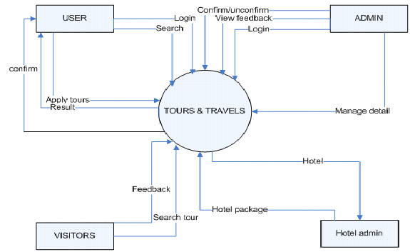

DFD Level 1 (Admin Side):
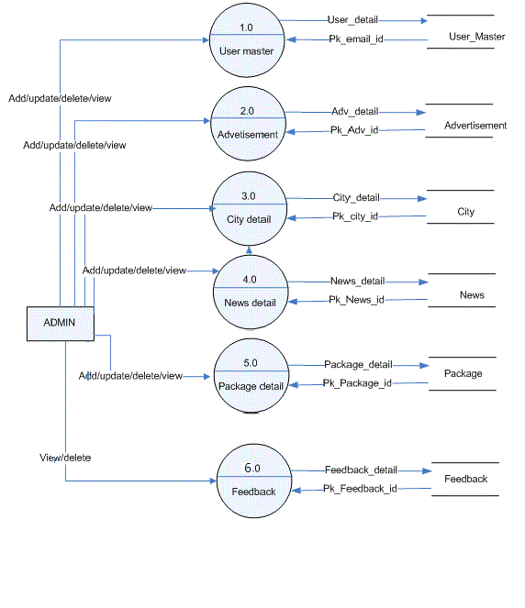

DFD Level 1 (User Side):

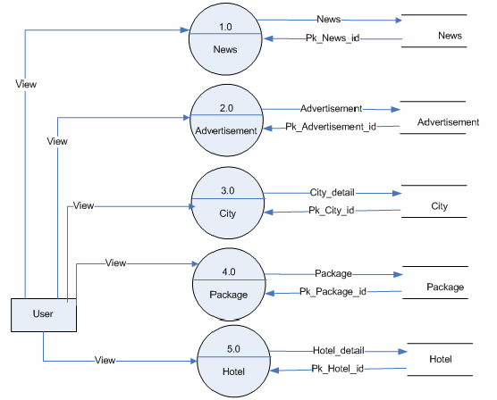

DFD Level 1 (Tour Side):
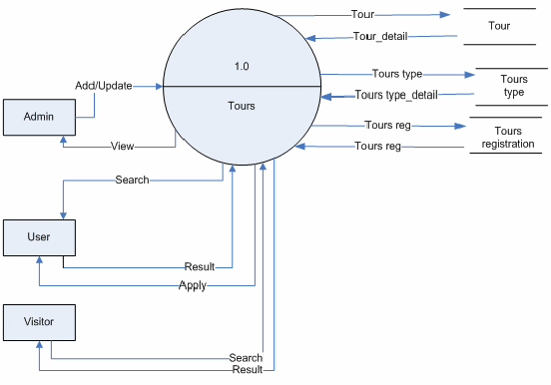
DFD Level 1 (Visitor Side):

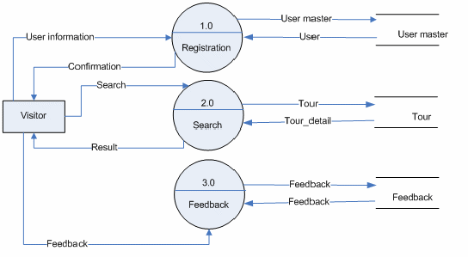
ERD (Entity Relationship Diagram):

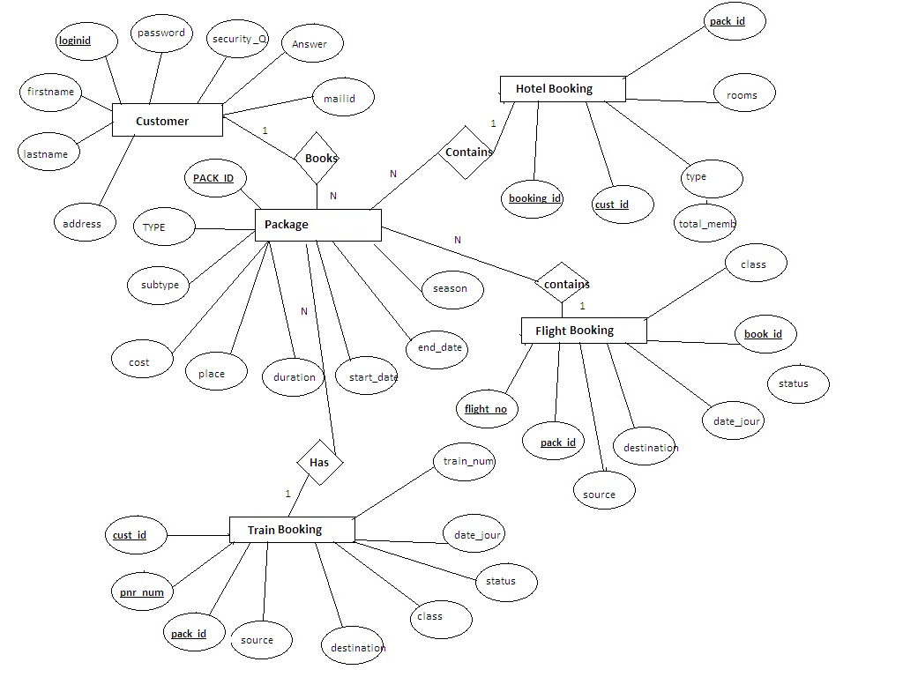

Data Dictionary:

Table name: Customer

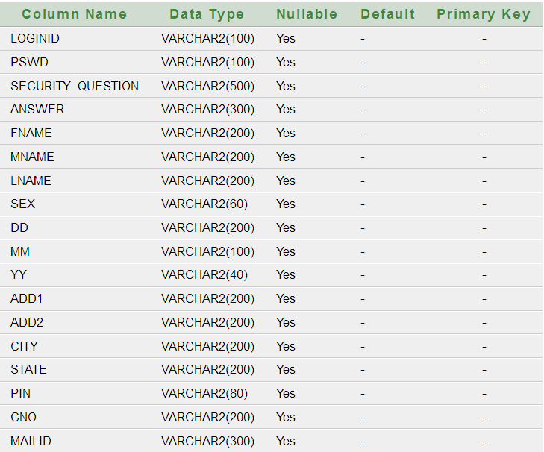

Table: FLIGHTBOOKING

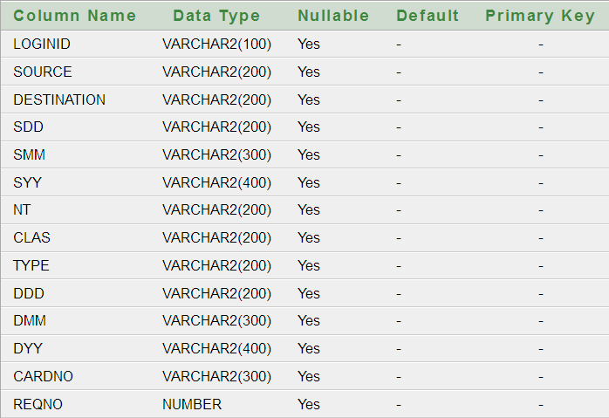

Table: Carbooking

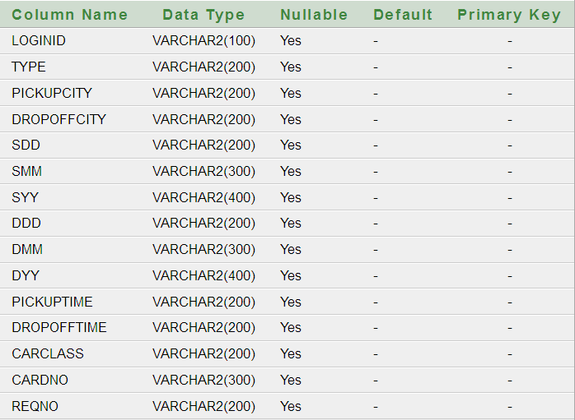

CRUISEBOOKING

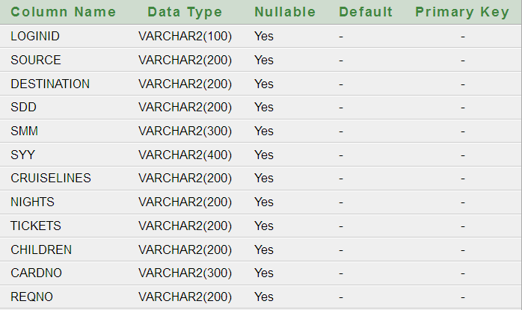

HOTELBOOKING

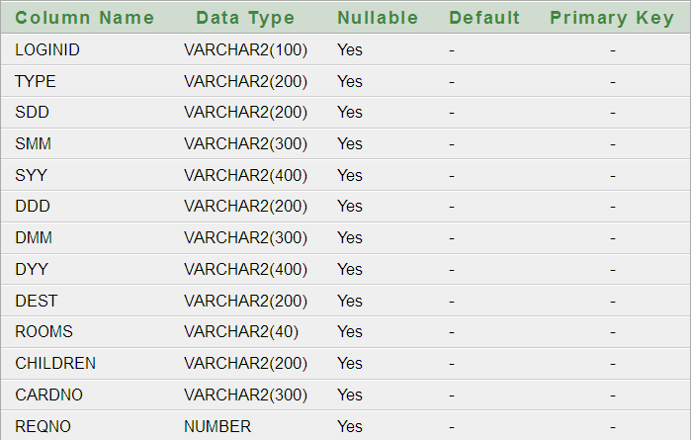

Future Scope:

While at first the system will specialize in agent based booking, in the future it is expected to be able to:

1) Make hotel and rental car reservations.

2) Issue "ticketless" reservations. For example, "ticketless" flight reservations will work as follows: travel agents making flight reservations will issue travelers confirmation numbers (and not a ticket). At the airline gate the traveler will show photo identification and the gate agent will locate the flight reservation and issue a boarding pass.

3) Easy payment methods (By credit card or Net banking or even Cash on Delivery).

4) So now this website is going to be a free services website.

5) This service gives more discount at a time of a current online booking.

